|  |  |
| --- | --- |
| http://images.clipartpanda.com/homework-clip-art-goldstar.gif | 5 Easy Homework Tips for Parents and Families |

Hello Parents and Families! Many questions and concerns I receive revolve around how to get homework done, how homework is a daily battle, etc. I’ve typed up five easy tips that you can follow to help both you and your child have a calm and simple homework time each day! Of course, these are only suggestions. Please do what works best for you, your schedule, and your child.

Tip 1: **Give your child a 20-30 minute “cool down” after school.** I often tell parents and families to try not to make your child do homework the moment they walk in the door. Your child does not stop working and learning from the moment they get to school in the morning right up until the bell at 2:20! They may be tired by the time they get home at the end of the day. Set a timer for the amount of time that works best for you. When the timer is up, they’ll be recharged and ready for homework time.

 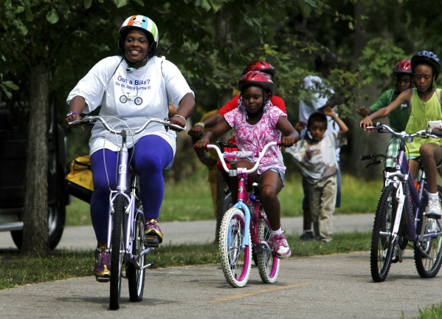

Tip 2: **Have a snack.** Letting your child have a small, healthy snack when they get home is great “brain food” that will allow them to recharge after school. Some great ideas for snacks could be cheese cubes, an apple, cup of cereal, peanut butter crackers, yogurt, etc. Snack time is also great “face to face” time you can have with your child to talk about their day and catch up with them.

  

Tip 3: **Make a Homework Station.** To help your child get into “homework mode” one suggestion I make is to give your child a **quiet, distraction free, and organized** place to work. I suggest the kitchen table or a desk- a place separate from where they usually play and away from the TV. When your child sits down at this spot, they need to understand it is work time.

Have supplies readily available (pencils, erasers, notebook paper, markers, crayons, scissors, etc.). You can organize them in something as simple as a plastic bin, silverware container from the dollar store, a Ziploc bag, or plastic drawers.

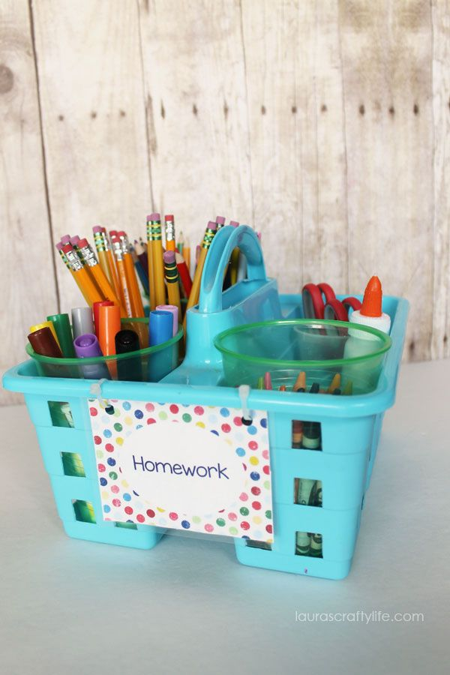 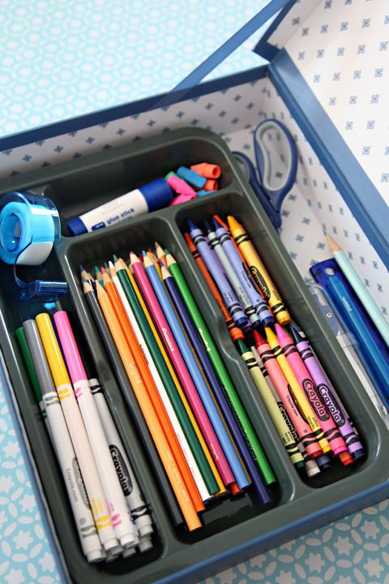

Tip 4: **Have activities ready for younger siblings.** One way to make younger children (particularly preschool age) feel included is to get them simple practice books (you can get these at the dollar store!) to work on while older children complete homework. This way they feel included while allowing older siblings to get their homework done quietly and without distractions.

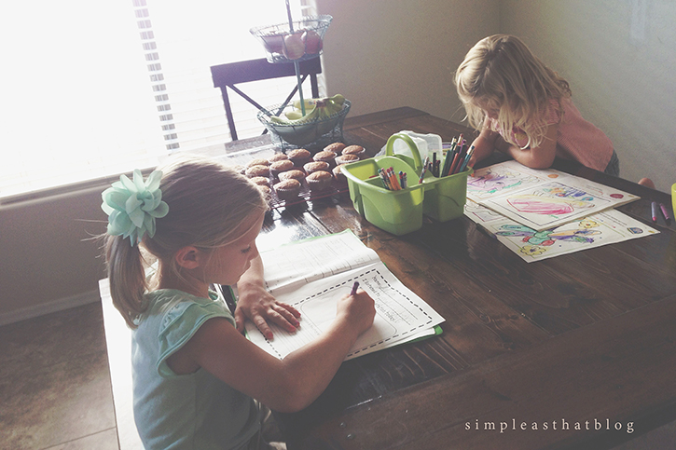

Tip 5: **Set expectations for your homework routine and STICK WITH IT!** This is the MOST IMPORTANT tip I can give you. Make sure to start with this routine from day one and stick with it as much as possible. Sit down and explain your expectations to your child (“When you get home from school, you have until the timer goes off to play. When the timer goes off, it’s homework time. When you finish your homework, you can play again.”). Say what you mean and mean what you say. ☺

**If you have any questions or concerns, please contact me anytime!**